**SAFE SCREEN**

Harini K, Harini K M

Panimalar engineering college, Chennai.

**Abstract: *The project encourages the promotion of safe mobile usage, which includes app locking and limiting the usage time of young users aged 5–18. Its main focus lies in providing age-appropriate access, facilitating parental monitoring, and maintaining a healthy balance in screen time.***

**Keywords:** Parental monitoring, age-appropriate access, safe mobile usage, screen time.

**1. Introduction:**

200 years ago, if someone had claimed that we could communicate with someone 20,000 km away from here, nobody would have believed it. However, today, the situation is completely different. Technological advancements in recent decades have sparked a revolution, propelling today's generation into the era of technology 4.0. Children are increasingly drawn to and addicted to social media platforms. While these platforms are undeniably useful for learning and staying informed about current events, excessive use can lead to addiction. It's crucial to strike a balance between utilizing these tools for productive purposes and avoiding overindulgence.

**2. Working:**

In the mobile settings, the Youth Guard feature operates as a default option, serving to regulate and enhance the safety of device usage, particularly for younger users. Leveraging the capabilities of the front-facing camera, Youth Guard employs facial recognition technology to accurately determine the user's age. This innovative functionality allows the system to differentiate between various age groups and tailor the device experience accordingly.

For users aged over 20, the Youth Guard imposes no restrictions, granting them unrestricted access to the device and its features. This approach acknowledges the maturity and autonomy of adult users, affording them the freedom to utilize the device as they see fit. Conversely, for users aged between 5 and 20, the Youth Guard feature is automatically activated upon device setup or first use. Upon detection of a user within this age range, the system initiates a prompt, prompting the user to set a predetermined time limit for their device usage session. The user can choose from predefined time intervals, such as 5 or 10 minutes, helping to responsible screen time management habits from a young age.

Furthermore, as an additional layer of protection and guidance, Youth Guard incorporates app locking functionality. This feature selectively restricts access to certain applications, particularly social media platforms, which are known to be popular among young users. By preventing access to these platforms, Youth Guard encourages young users to explore alternative activities that promote learning, creativity, and social interaction beyond the digital realm. In essence, Youth Guard serves as a proactive tool within mobile settings, fostering responsible device usage habits among young users while empowering them to engage safely and purposefully with digital technology. It emphasizing its role in promoting safe and responsible device usage among younger users.

**3. Features and its uniqueness:**

Time Limit and Device Auto-Lock: This feature establishes a default time limit for mobile usage, typically set at 5 minutes or 10 minutes. After the specified duration of usage, the device automatically locks, prompting the user to take a break from screen time. By enforcing regular breaks, this feature promotes healthy screen time habits and encourages young users to engage in physical activity, social interaction, or other non-screen-related activities. Parents can customize the time limit based on their preferences and recommendations from health professionals to ensure an appropriate balance between device usage and other activities.

Facial Age Recognition: Youth Guard employs facial recognition technology using the front camera to scan the user's face and accurately determine their age. If the user's age falls within the designated range of 10-18 years old, certain applications deemed potentially inappropriate or unsuitable for younger users, such as Instagram or other social media platforms, are temporarily locked. This proactive approach helps protect young users from exposure to content that may not be suitable for their age or maturity level, promoting a safer and more age-appropriate digital environment. Parents can have peace of mind knowing that their child's access to potentially harmful content is restricted, while still allowing them to use other educational or entertainment apps.

Emergency Call Access: In situations where immediate assistance is required, such as emergencies or urgent matters, Youth Guard ensures that young users have access to emergency calling features. This functionality allows users to quickly and easily contact emergency services, trusted individuals, or designated contacts stored in the device's emergency call list. By prioritizing safety and accessibility, Youth Guard provides young users with the means to seek help or assistance whenever needed, enhancing their overall safety and well-being while using mobile devices.

**4. Future Impacts:**

Youth Guard is a tool that promotes healthy screen time habits and breaks from device usage, aiming to improve digital well-being among young users. It restricts access to harmful content based on age, creating a safer online environment. Parents can benefit from the tool's parental control tools, allowing them to monitor their child's device usage. Youth Guard also helps develop responsible digital citizens by instilling responsible screen time management habits and age-appropriate content consumption. The tool also incorporates technological advancements like facial age recognition, addressing specific societal needs. Future iterations may incorporate even more sophisticated features to further enhance digital safety and well-being.

**5. Technology used:**

Hardware:

* Smartphones/Tablets.
* Server infrastructure to store data.

Software:

* Operating system-Android (Android studio with java/Kotlin), IOS (X code).
* Kotlin is also a language used by android developers that boost productivity, satisfaction and code safety Java is widely used programming language for coding web applications.
* Content filtering service: If the users are opening the unwanted pop up message, it will automatically block.
* APIs and Machine learning.

**6. Source code:**

def user_opens_device_settings():

print("User opens device settings.")

def is_youth_guard_enabled():

return input("Is Youth Guard enabled? (Yes/No): ").lower() == "yes"

def detect_user_age():

return int(input("Enter user's age: "))

def age_over_20(age):

return age >= 20

def age_5_to_20(age):

return 5 <= age <= 20

def set_time_limit():

return int(input("Set time limit (in minutes): "))

def app_lock_prompt():

return input("Would you like to set app lock? (Yes/No): ").lower() == "yes"

def user_sets_app_lock():

print("User sets app lock.")

def device_settings_saved():

print("Device settings saved.")

def main():

user_opens_device_settings()

if not is_youth_guard_enabled():

print("Youth Guard not enabled. Exiting.")

return

age = detect_user_age()

if age_over_20(age):

print("No restrictions for users aged over 20.")

device_settings_saved()

return

elif not age_5_to_20(age):

print("Age limit not met. Exiting.")

return

time_limit = set_time_limit()

print(f"Time limit set to {time_limit} minutes.")

if app_lock_prompt():

user_sets_app_lock()

device_settings_saved()

if __name__ == "__main__":

main()

**OUTPUT:**

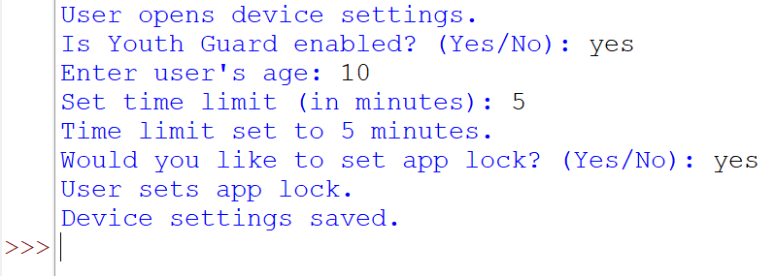

**5. Conclusion:**

Youth Guard is a tool designed to promote responsible digital device usage among young users aged 10-18. It includes features like Time Limit, Device Auto-Lock, Facial Age Recognition, and Emergency Call Access. Youth Guard encourages breaks from device usage, limits access to inappropriate content, and provides emergency call access. Its future impacts include fostering responsible digital citizenship, parental control, and technological innovation. Youth Guard lays the foundation for a safer, healthier digital future.

Top of Form